Project Proposal for Misunderstood World

Organisation Overview:
Misunderstood World is a streetwear brand birthed in the streets of Cape Town in the 2000s for people who always felt like outsiders to the world we all live in, founded by two boys from the cape flats with the mission to bring about confidence within those who always felt left out and a strong vision to empower the silent faces of the youth to elevate.

Website Goals and Objectives:
The website will be designed with the intention to bring about awareness for street culture and street wear and sell clothing designed for fashionists. Key performance areas entail how social media engagement will be done and how sales will be handled.

Proposed Website Features and Functionality:
Essential features of the website include a homepage, about us, contact page, products page, with a wish list for items that a user would want to save. Other features include a category list for the different types of clothing pieces and a history page that overlays the whole story behind the brand.

Design and User Experience:
The overall design aesthetic and branding is a simple street design with a white and blue shades colour scheme involving a typography with font choices such as Aerosoldier and Funkydori/Groovy style. The layout and design will follow the typical useful bait layout with the UX design wireframe that will allow exploration of UX concepts without committing to final design details. The following image will serve as an example to our design: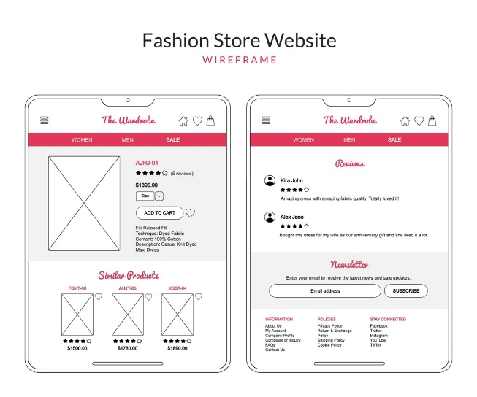
Technical Requirements:
Technical Requirements will include the use of languages such as HTML, JavaScript and CSS. Websites and tools such as vercel.com and GitHub will be used to deploy our website to the internet. cPanel will be used to host our final website. A domain name will be purchased and run through on GoDaddy.com.

Timelines and Milestones:
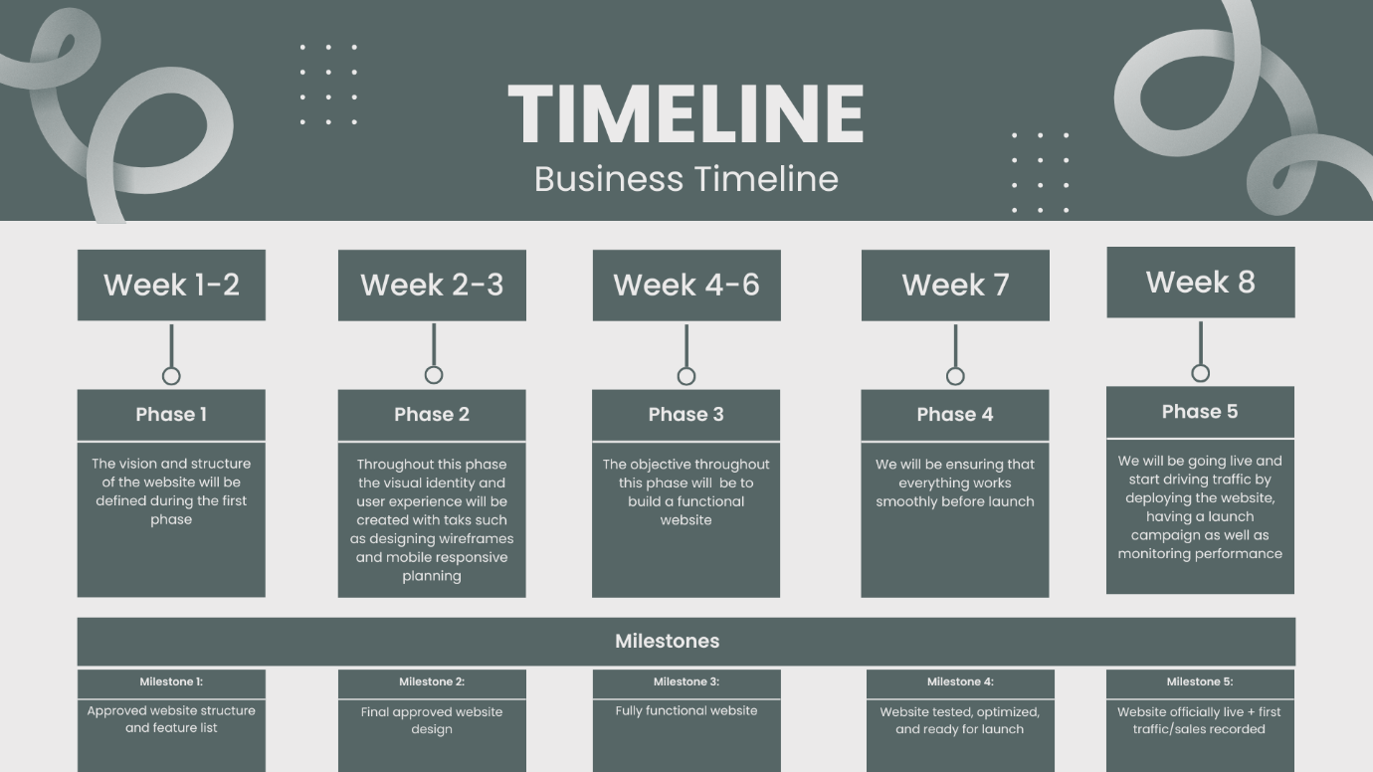

Budget:
- Planning and Strategy
Item | Cost
Market research and Planning | R2,000
Sitemap and feature planning | R1,000
Subtotal | R 3,000

- Design
Item | Cost
Wireframes | R2,000
Full website design | R5,000
Subtotal | R 7,000

- Development
Item | Cost
Website development (front-end + back-end) | R10,000
E-commerce functionality | R4,000
Payment gateway integration | R2,000
Subtotal | R 16,000

- Testing and Optimisation
Item | Cost
Website testing | R1,500
SEO setup | R2,000
Subtotal | R 3,500

- Ongoing Monthly Costs
Item | Cost
Hosting and domain | R150 – R500
Platform subscription | R500 – R1,200
Subtotal | R 650 -R1,700

Total: $±31,$
Sitemap:
